**Антикоррупция**

[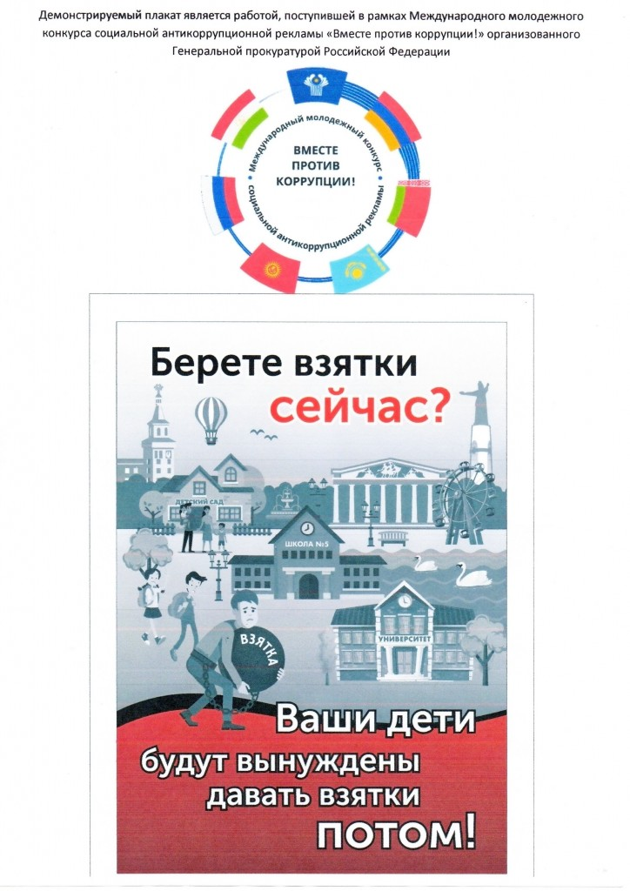](http://petelino.depon72.ru/wp-content/uploads/sites/193/2019/10/%D0%B0%D0%BD%D1%82%D0%B8%D0%BA%D0%BE%D1%80%D1%80%D1%83%D0%BF%D1%86%D0%B8%D1%8F.jpg)[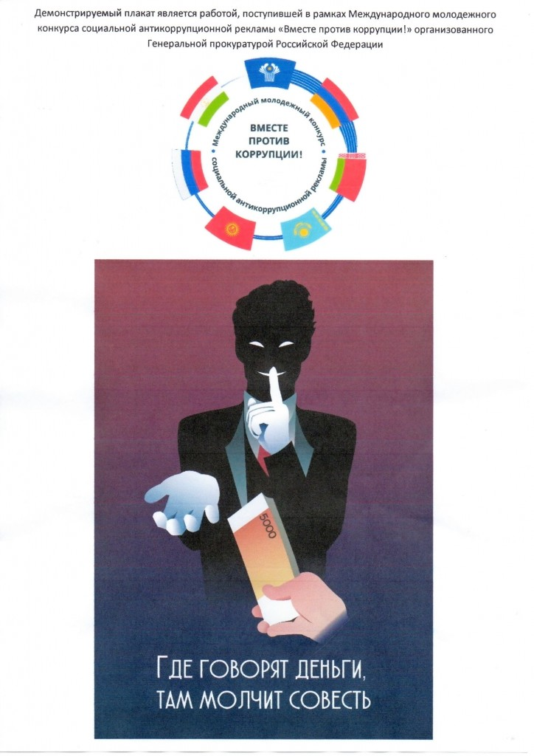](http://petelino.depon72.ru/wp-content/uploads/sites/193/2019/10/%D0%B0%D0%BD%D1%82%D0%B8%D0%BA%D0%BE%D1%80%D1%80%D1%83%D0%BF%D1%86%D0%B8%D1%8F2.jpg)