Опубликовано 13.01.2011 11:48

[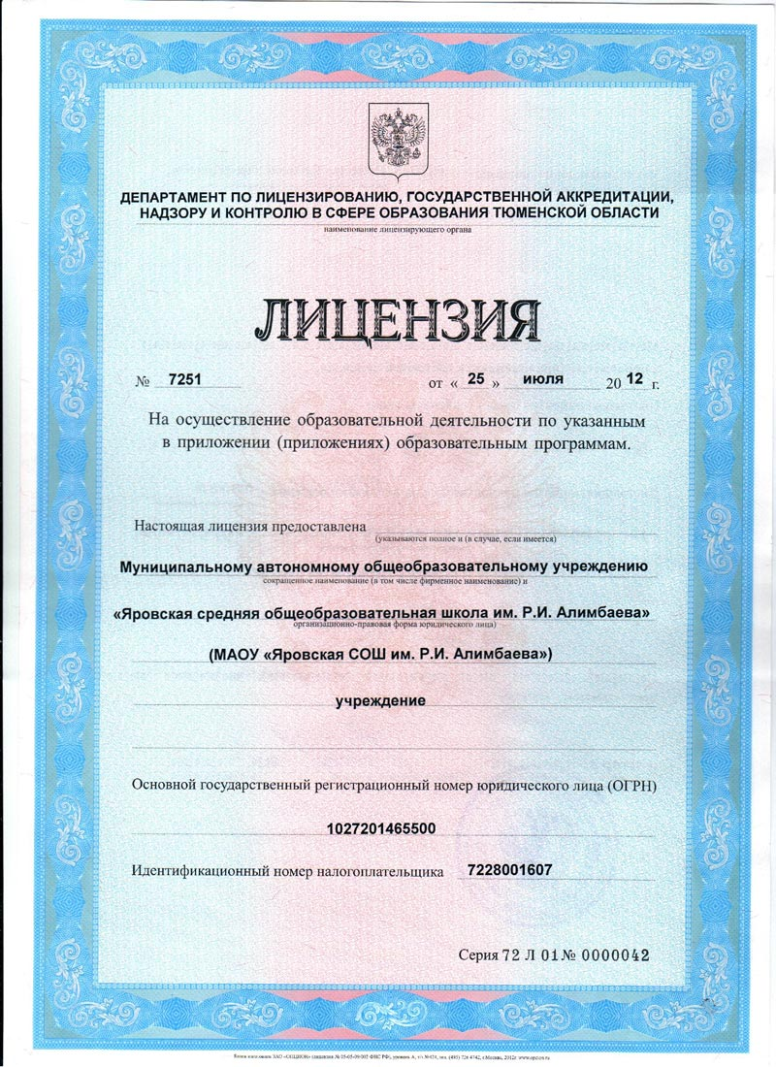](http://ярсош.рф/images/stories/lisenz1.jpg) [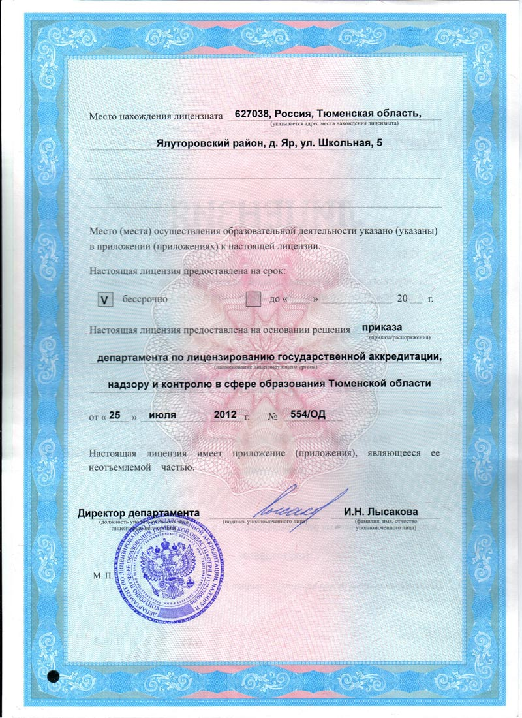](http://ярсош.рф/images/stories/lisenz2.jpg) [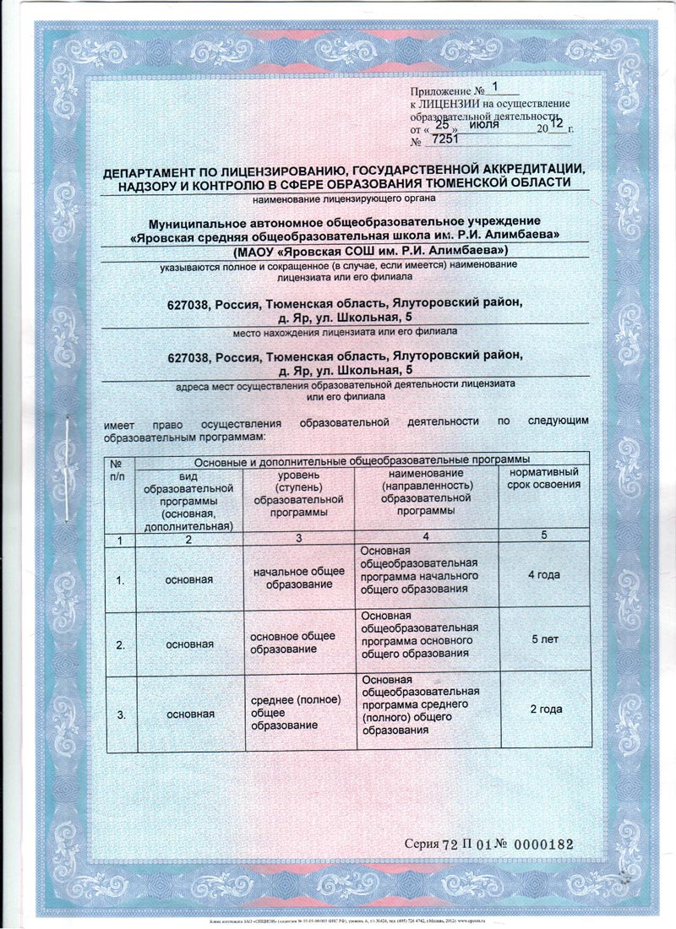](http://ярсош.рф/images/stories/lisenz3.jpg) [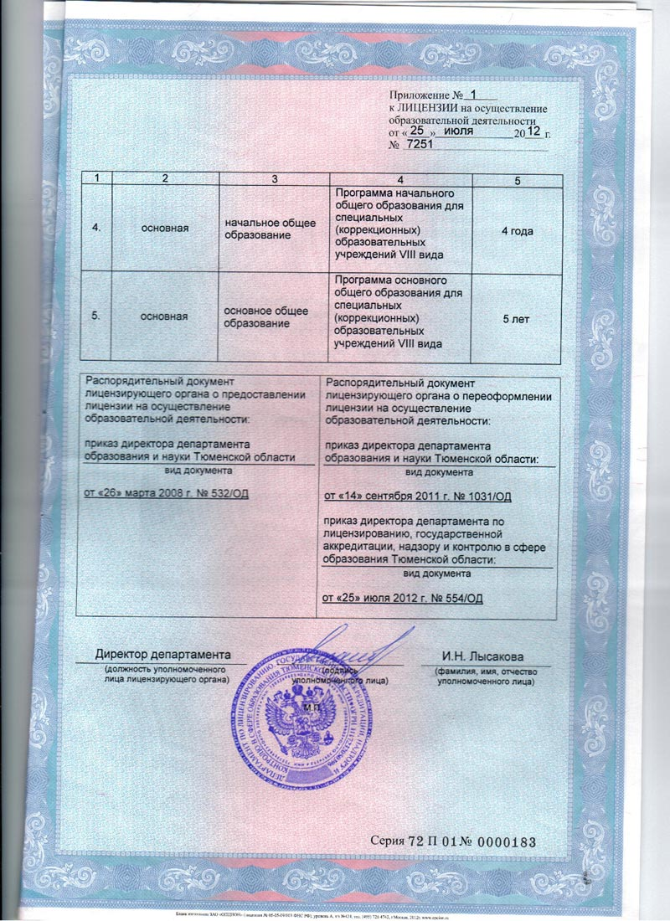](http://ярсош.рф/images/stories/lisenz4.jpg) [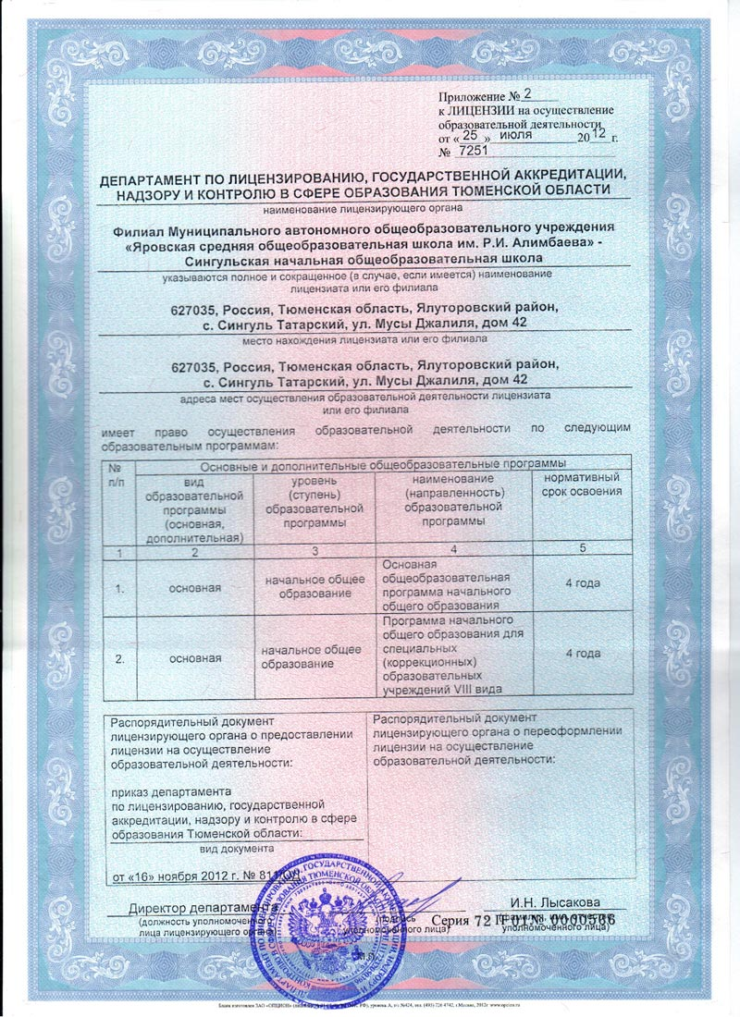](http://ярсош.рф/images/stories/lisenz5.jpg)