[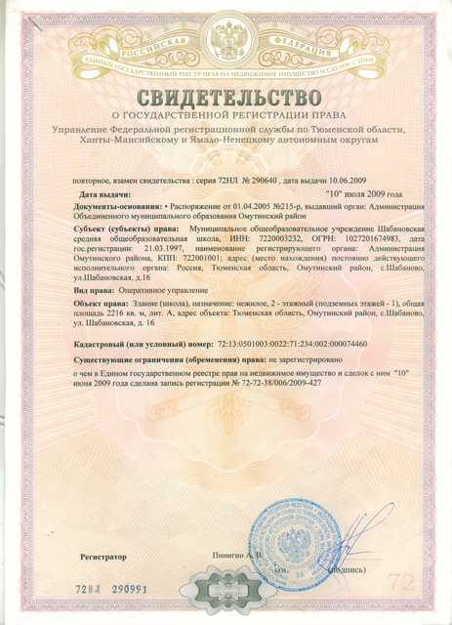](https://admin.admtyumen.ru/files/upload/EDU/School-51742/Image5.bmp)